**Coding Convention**

**1/ C# Best Practices**

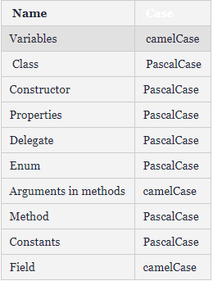

Const variable: ALL_UPPER_CASE

Use prefix I for Interface: IAuthRepository

Use “Is”, “Has”, “Can” for Boolean values: “IsVisible”, “HasChildren”, “CanExecute”

Always use Properties instead of public variables:

~~NO: public string name;~~

YES: public string Name { get; set; }

**2/ Typescript Best Practices**

Use Prettier

Use const as much as we can

Namespaces, function, function parameters, methods, fields are camelCased

myFunction(), myMethod(), myField

Class, enums and enum members are TitleCased

MyClass, MyEnum, MyEnumMember

Use string, number instead of ~~String, Number~~  (primitive vs non-primitive)

**3/ Angular Best Practices**

Component

all-lowercase-with-dash

**4/ HTML**

Comment what each major block does